Itgalpura, Rajanukunte, Bengaluru - 560064

**School of Engineering**

A Project Report on

# TELEGRAM BOT USING RASPBERRY – PI

Submitted in partial fulfillment of the requirement for the course

Innovative Project – Raspberry-pi using Python (**CSE 1003**)

Submitted by   
 Group: IPR 53

|  |  |
| --- | --- |
| Student Name | Roll No |
| KHUSHI S M | 20211CSD0045 |
| AMRUTHKUMAR BANDIHAL | 20211CAI0158 |
| ARYAN RAJESH | 20211CIT0143 |
| YADHUNANDHAN R | 20211CIT0132 |
| TARUN KUMAR A V | 20211ECE0110 |
| V RAHUL BALAJIGA | 20211EEE0035 |

Under the supervision of

**Guide name: Mr. Amogh Pramod Kulkarni**

**Designation: CSE Professor**

**Department: Department of Computer Science Engineering**

Dec-2022

**Abstract (100-150 words):**

* Overview:

Turn on and off a LED using a Telegram bot. It sounds trivial, but it will be very useful for future applications in the Raspberry Pi world.

* Outcomes:

Once the bot is responding for the program. When clicked on start and type in any commands like /hi, /time, /file, /logo, or /audio and should be replied accordingly. Ultrasonic sensor used in the project gives us the distance from where the command is being requested.

* Objectives :

Bots are really useful. There are many bots which can facilitate your life. TrakBot can track your packages, ExchangeRates can convert values, TempMail provides a temporary email, PollBot, WeatherInfo and many other. Tens or hundred apps concentrated in one.

**Hardware, Software and tools used:**

HARDWARE:

1. Raspberry-Pi
2. Ultrasonic sensors
3. LEDs
4. LCD display
5. Resistor

SOFTWARE:

We have imported the following packages for our project:

1. Telepot: Using Telegram Bot in Raspberry Pi is made possible by the python package called Telepot. We need to install this package on Raspberry Pi by using the following commands on Lx terminal.
2. Socket: The function socket() creates a socket and returns a descriptor which will be used by other functions.
3. Geocoder: Geocoder is a simple and consistent geocoding library written in Python.
4. Gpio: This package provides a Python module to control the GPIO on a Raspberry Pi. Each model of the Raspberry Pi has a set of General-Purpose Input/output (GPIO) pins along the top edge of the board. These can be used for connecting and communicating with all manner of electronic components, acting as a physical interface between the Raspberry Pi and the outside world.
5. Rpio
6. Os: Raspberry Pi OS is a free operating system based on Debian, optimised for the Raspberry Pi hardware.

**Block diagram & Description:**

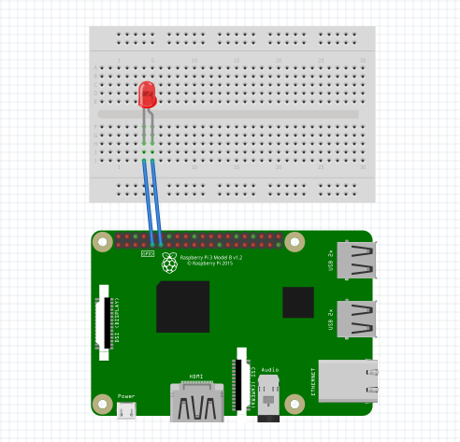

Raspberry Pi’s powerful ARM architecture and open-source Linux based Operating System helps us a lot in getting our projects online in no time. In our project we have used telegram combined with raspberry pi to **share data (files/photos/videos/audios/text) between Raspberry Pi and our Mobile phone through a popular chat application called Telegram.**

Telegram is a chat based application available in play store for Android (also available for Iphone and windows) that is very similar to Whatsapp. It has over 100 million downloads (as on 5-10-2017) on play store and people claim it to be faster and more functional than Whatsapp. One special features of this application is that they support bots. Meaning this smart phone application can not only be used by Humans but also by machine. In our case the machine will be Raspberry Pi. Once you train Raspberry Pi on how to act as a bot, anyone (if you make it public) can chat with your Raspberry Pi like chatting to any normal person and even share Photos Pictures Documents and Audio files.  We can even train it to be your own Personal assistant.

 First we have to request the Bot Father to create us a new Bot.  Botfather is a Bot by itself, it will guide you to create a new bot for you.  The bot asks for few details like name of Bot and the user name of the bot. Fill those details and we have to remember the username for we will needing it in future.

After this process the Botfather will give you a Token for access. This is like the password for our bot, people can control program your bot using this token key. So we have to keep it safe and not share it with anyone.

Using Telegram Bot in Raspberry Pi is made possible by the python package called Telepot. We need to install this package on Raspberry Pi. Once Telepot is imported into Raspberry we can use this package in our python program to communicate with our Telegram Bot.

**Results (Model’s image):**

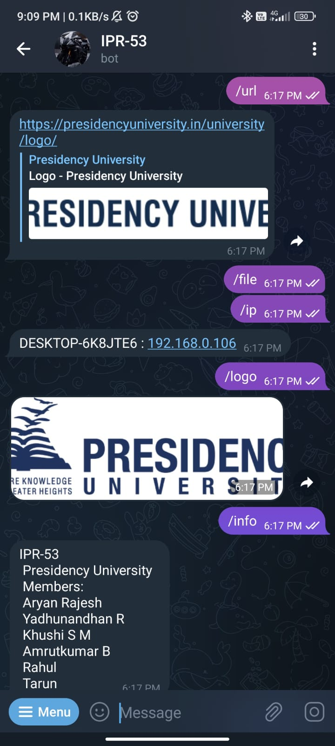

The first step is to **import all the libraries**, here we will obviously need the teleport library to use the Telegram bot. We also make use of the time, timedate library to read the current time for Raspberry pi.  Then we create an object now in which the value is stored.

The next step is to **create a function for taking actions based on incoming commands** from Telegram app on Mobile. Here the name of the function is action. It is inside this function where the bot comes to life.

Our bot cannot initiate a conversation on its own, it can only reply if we ask something. So each time we ask something there will be chat id. This chat id is something similar to an address, only using this chat id a bot can reply back to us. So the first step is to read the chat id and the message it is trying to say to us. We also print the received message for debugging purpose.

We have also used ultrasonic sensor to get the distance from where the command is being requested. Ultrasonic / level sensors measure the distance to the target by measuring the time between the emission and reception. It uses a single ultrasonic element for both emission and reception.

**Challenges faced:**

These are some of the challenges we faced while building the project:

* SD card damages.
* Server down.
* Coding.
* When clear history command is given the bot runs into infinite loop.
* Internet issues.
* Problem with /audio and /file if we have not changed directory to a proper file that is available on your Raspberry Pi.

**Conclusion:**

This can be developed into a more advanced project by involving more commands for a specific use, for example, we can customize this bot into a personalized assistant which would involve many commands as per user’s needs.

There is not much hardware involved in this project but the software is complex as it involves writing separate functions for each and every command we wish to use.

Bots are really useful. There are many bots which can facilitate your life. TrakBot can track your packages, ExchangeRates can convert values, TempMail provides a temporary email, PollBot, WeatherInfo and many other. Tens or hundred apps concentrated in one.